MODULE 4
- 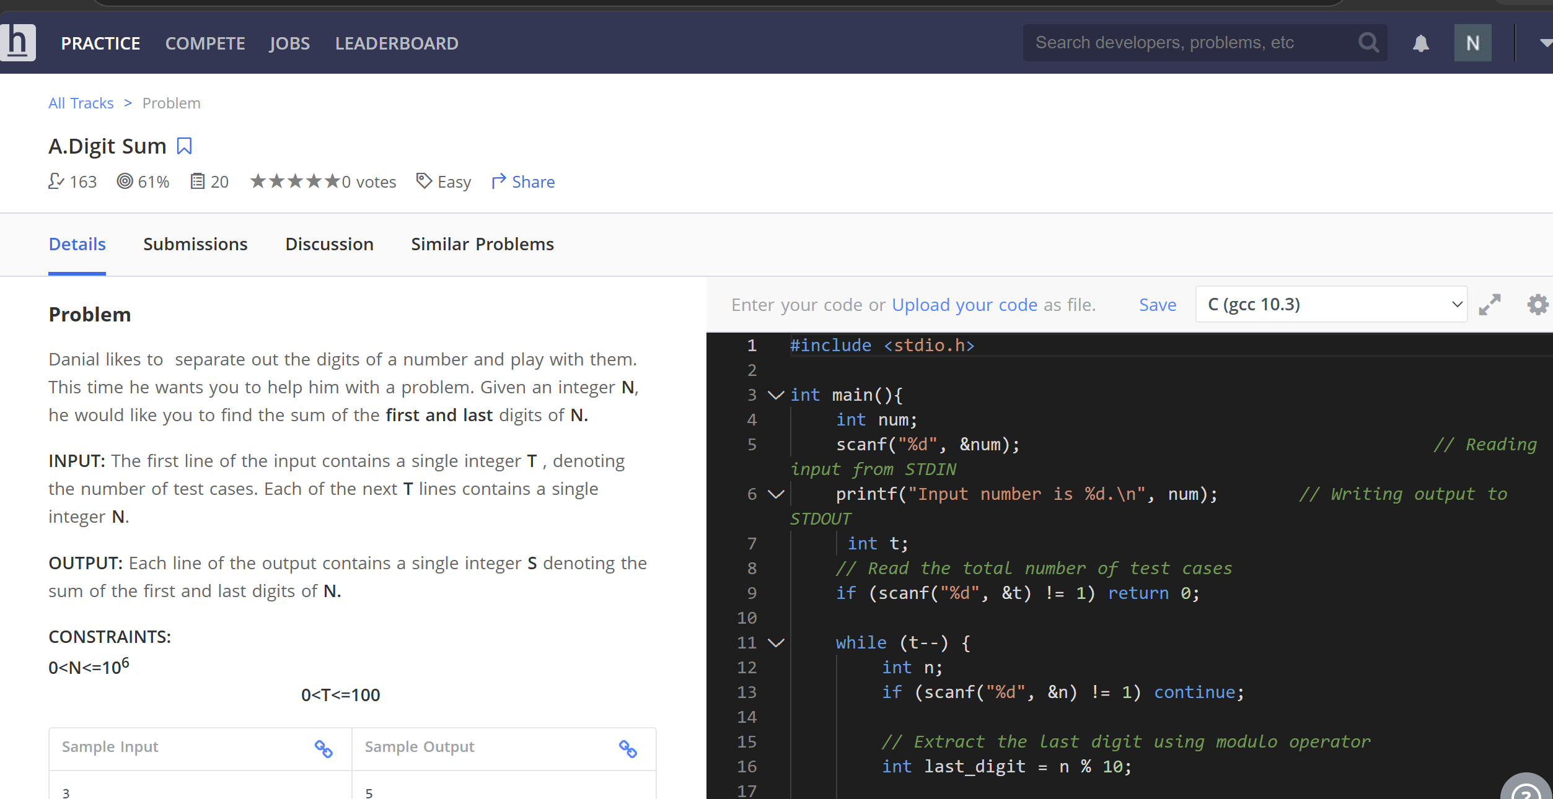

2.
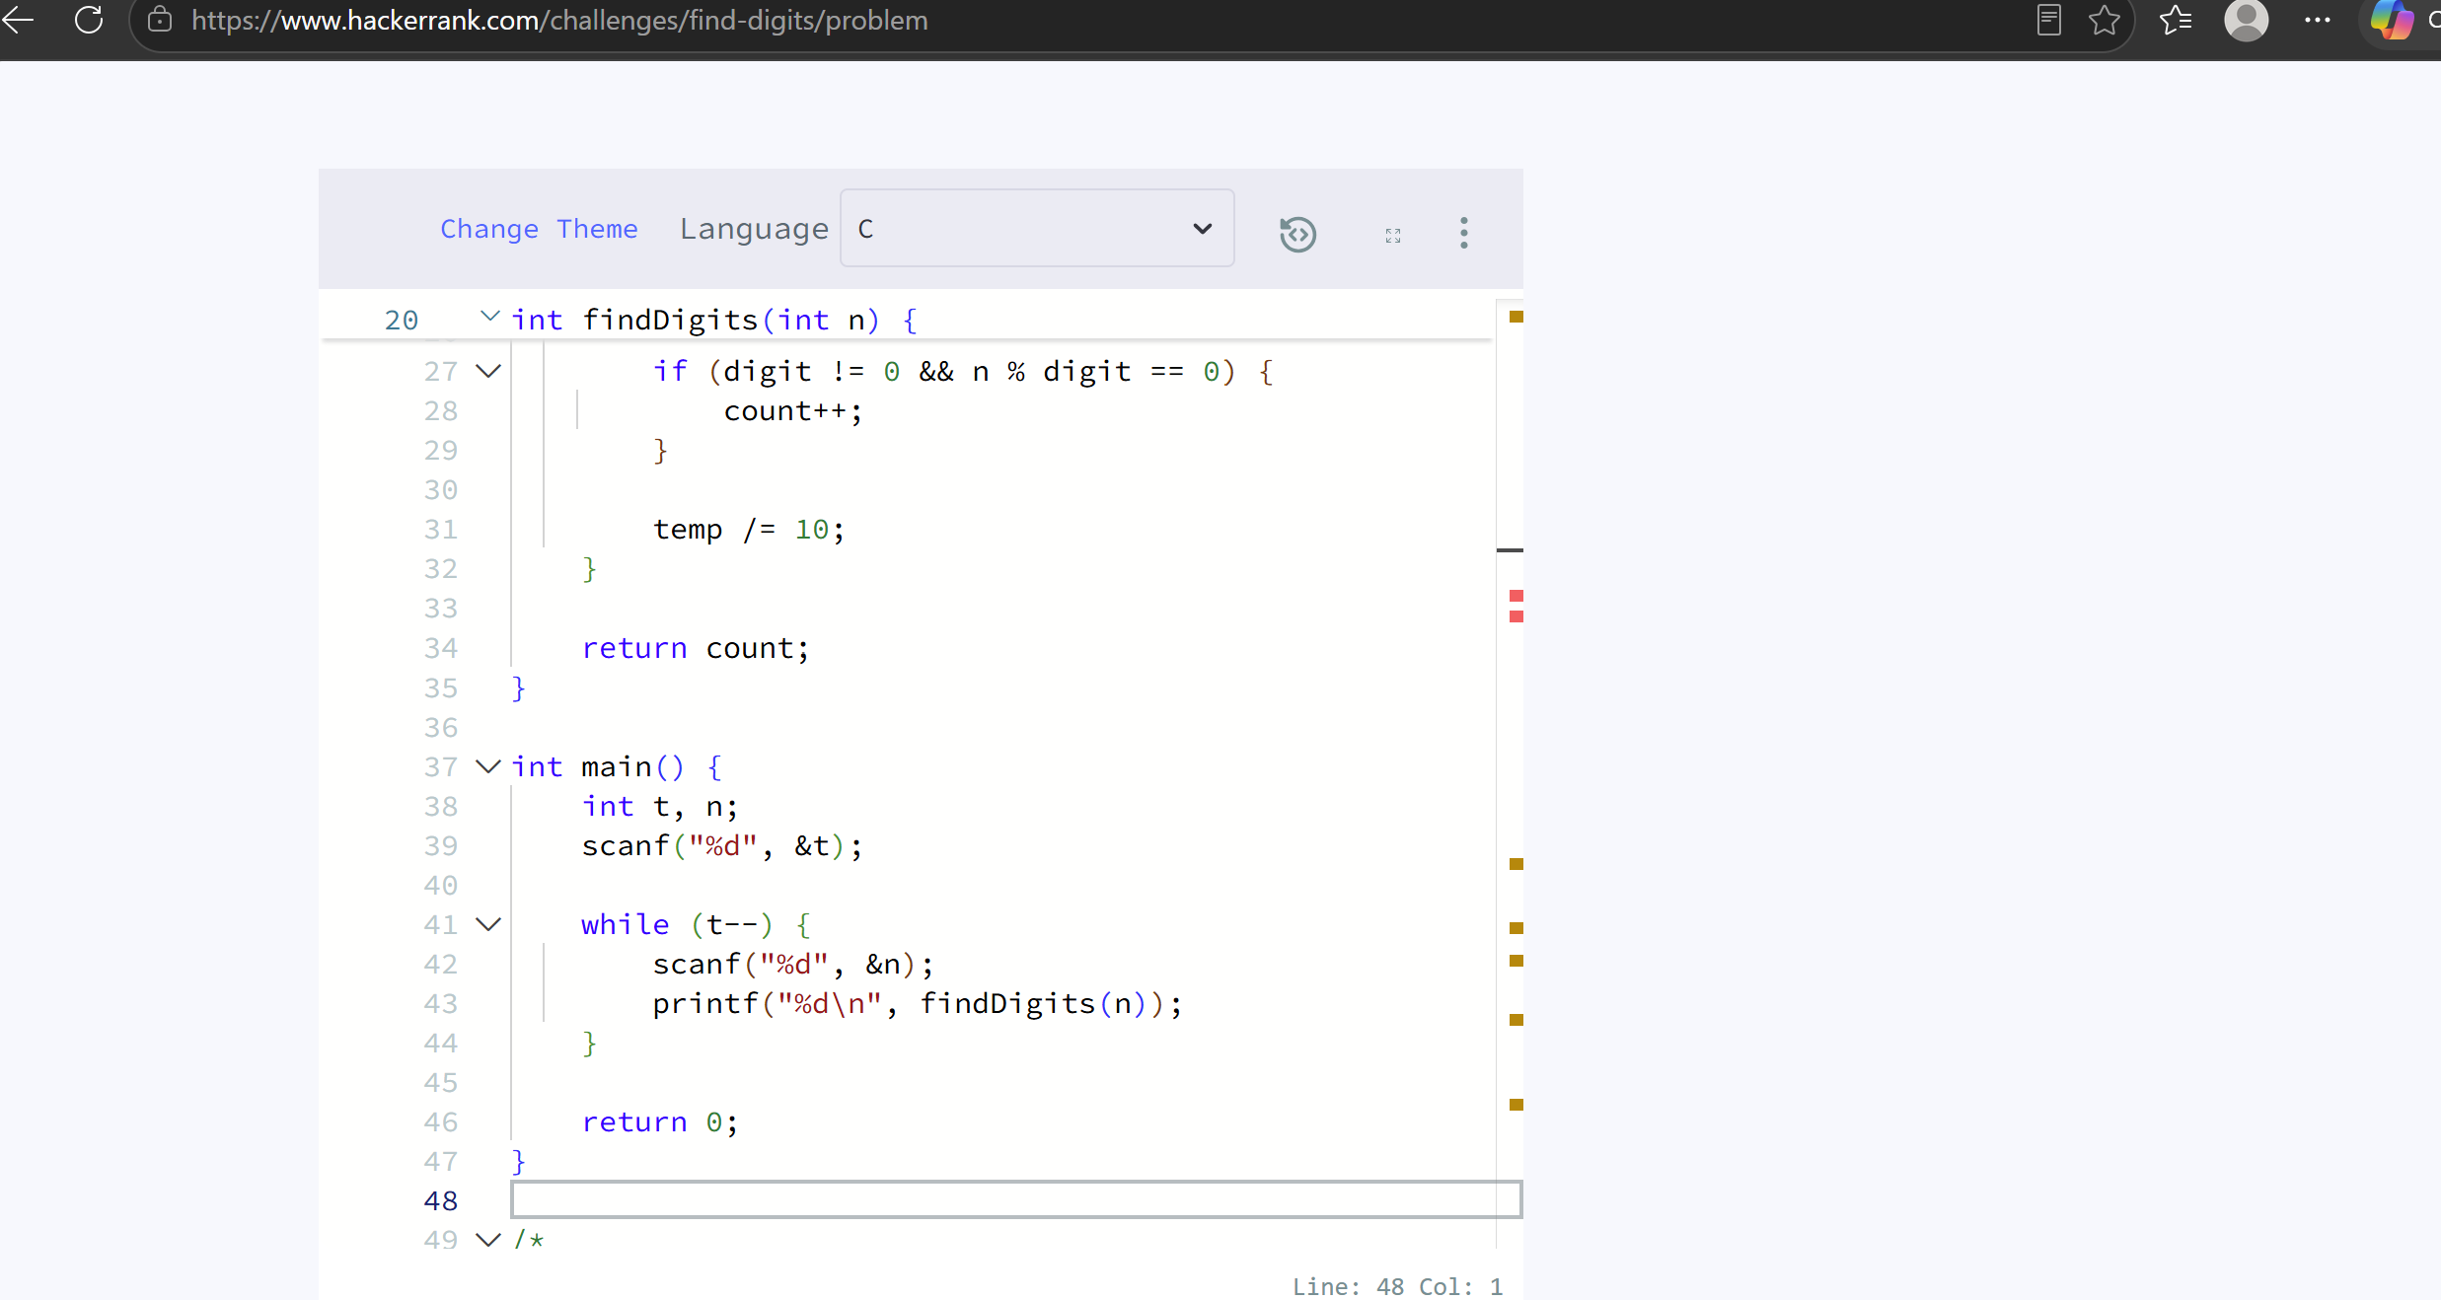

3. Subtract the Product and Sum of Digits of an Integer - LeetCode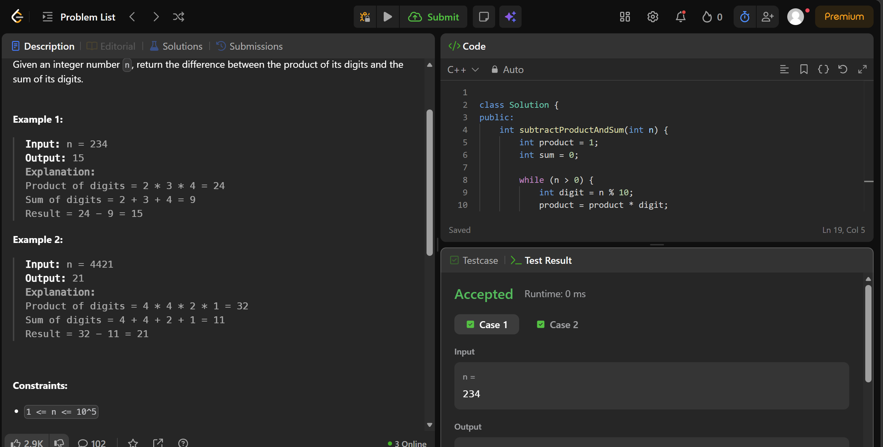
4. Count the Digits That Divide a Number - LeetCode
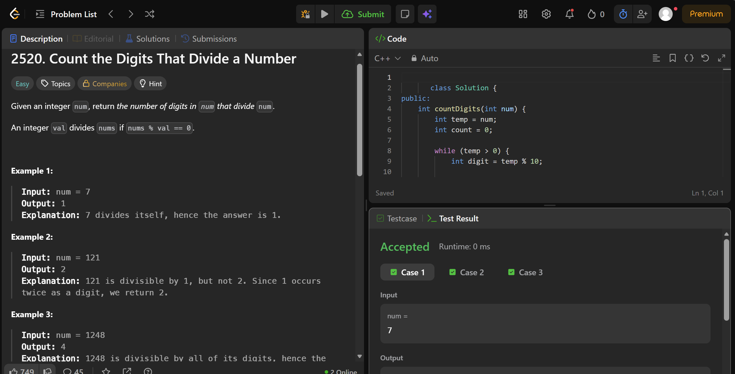
5. Palindrome Number - LeetCode
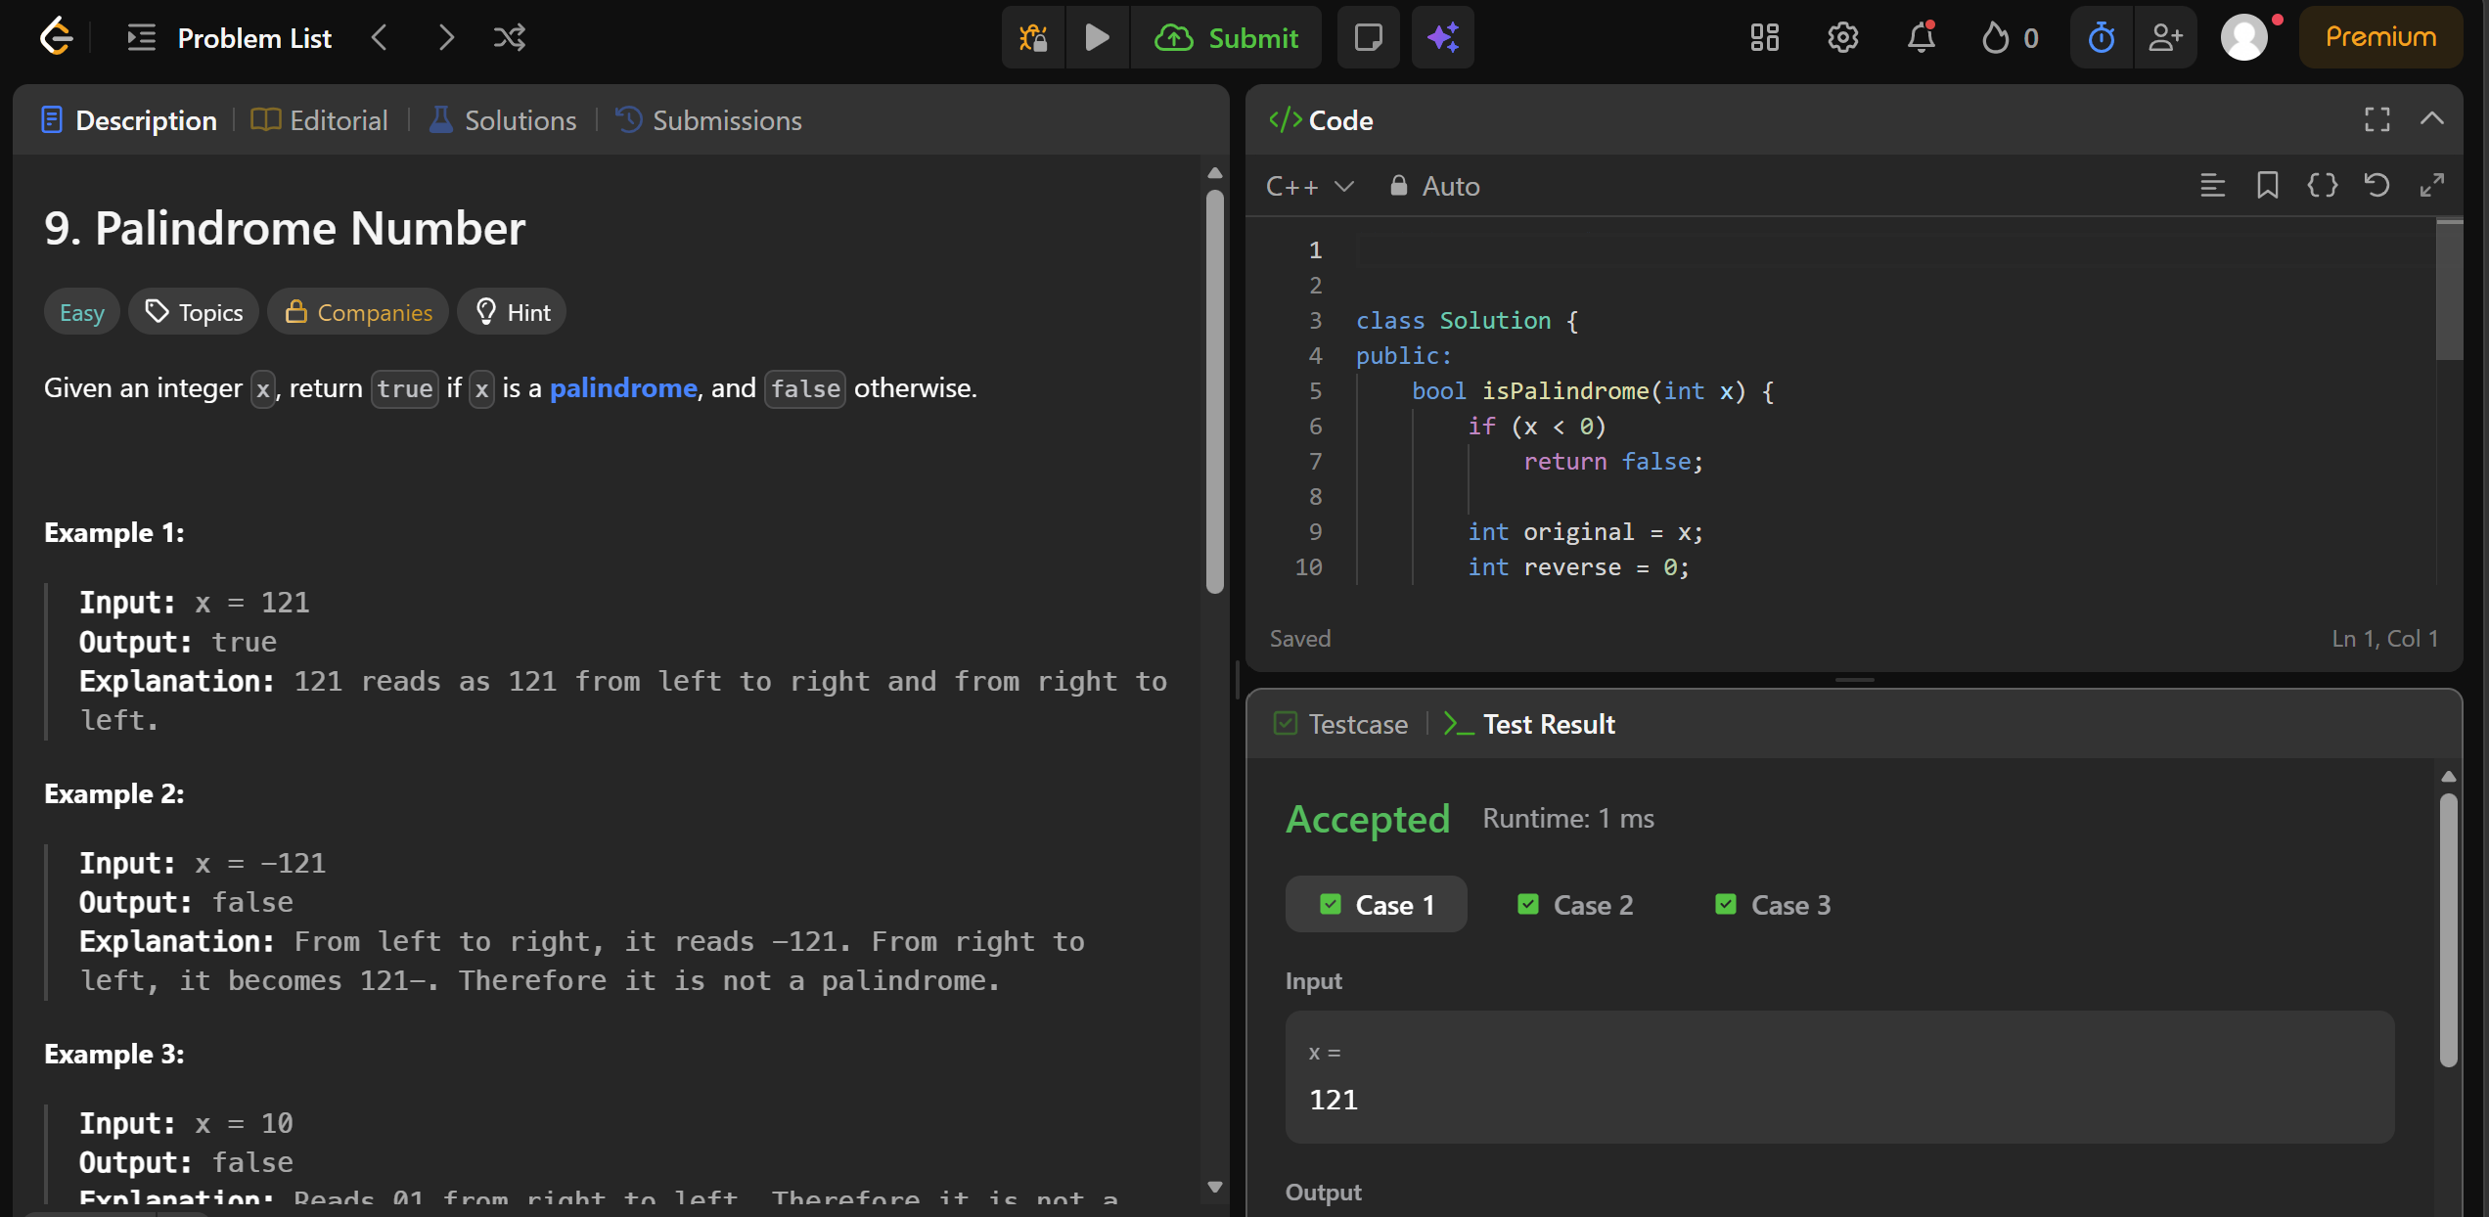
6. Perfect Number - LeetCode


